# CS 340 README

## About the Project/Project Title

This project is to help find good candidates for search and rescue training. This is done with the help of five animal shelters in the Austin, Texas region. To help find good candidates this program is designed to find which shelter has animals that fit the desired qualifications.

## Motivation

The reason to create this database is to help search and rescue groups find animals that can be trained to be helpful in saving lives. This truly is a win win. The animals find good homes and learn good skills and this in turn helps save people. This code will also be published on GitHub so that other groups of people can copy the code and adjust it so that it will be beneficial to their needs.

## Getting Started

To get this project started you will need to begin by installing the database. This can be done by simply opening the mongo database and typing mongoImport __collection animal -–file /usr/local/database/acc_shelter_outcomes.csv –type csv –headline. Once this command is ran, you can ensure that it worked by typing show dbs. If you see AAC, that database has been loaded. To make sure that there is data in the database, type use AAC. Then type db.animals.find().pretty(). This command will give a random animal that is in the database in an easy to read manner. There is an easy to use dashboard that will display all of the animals that are in the Austin, Texas area. There is a filter option located below the database that will allow users to choose between water rescue, mountain rescue, and disaster rescue. When one of these filters are used it will display a bar chart that will show how many animals fit the list of requirements. There is also a map that will show where each animal is located and what their name and id number is.

## Installation

For this to work you will need to get two different types of software. The mongoDB and python3. MongoDB can be downloaded at [www.mongodb.com](http://www.mongodb.com/). Python3 can be downloaded at python.org. Just follow the onscreen guide to download each of these. Now that the programs that are needed are downloaded, head to GitHub.com and search for Grazioso Salvare AnimalShelter. Once the repo is found just download it and run it, or make the customizations that are needed to be made and then run it. It is important to note that you must be logged into the database to use the program.

## Usage

### Code Example

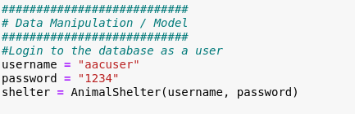

This code shows how and where you can change the username and password.

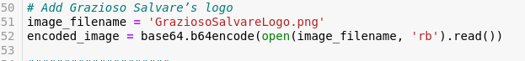

This code shows you where you can change the logo that will be used.

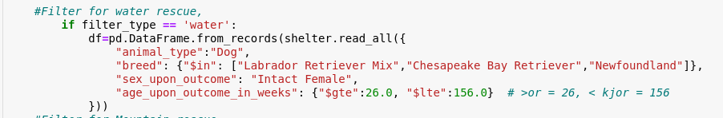

This code shows how the filter works for water rescue. It is the same set up for all of the filters, just changing the information that is needing to be found.

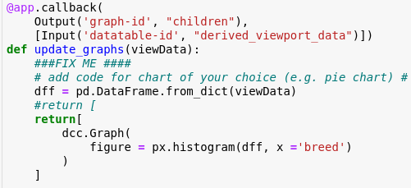

This code shows the histogram chart that is being used. If a different graph is wanted this is the code to change.

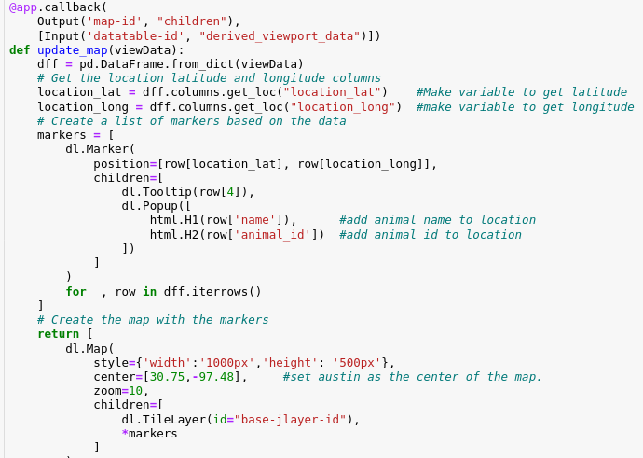

This code shows how the map is connected to the database.

### This is an example of the python code that will allow users to log into the database with usernames and passwords. It also show how user can create a new document, or read documents that are already in the collection.

### Tests

The tests are just print statements that will display on the screen when the process has run successfully.

1. Showing the Logo and unique identifier.

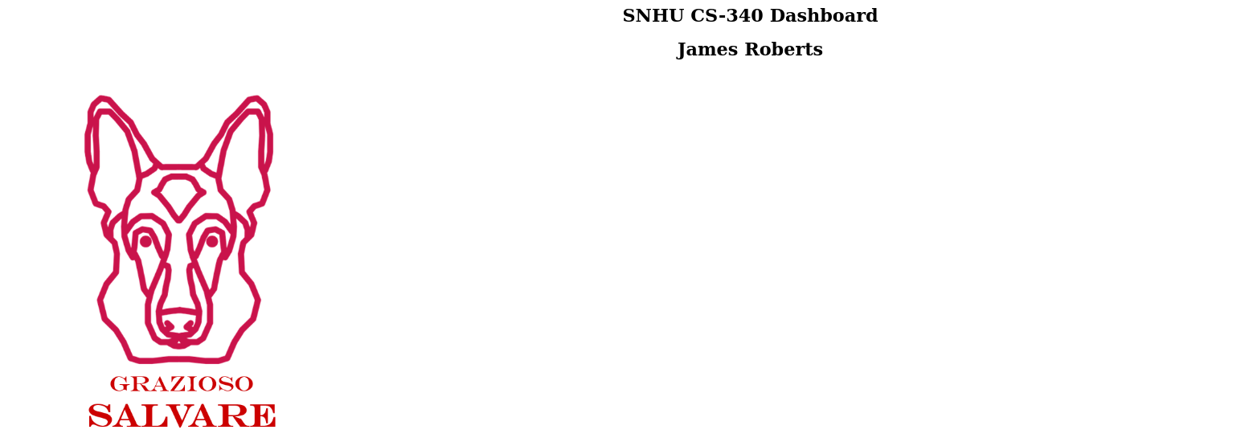

1. List of tests printed Showing that all tasks were loaded. 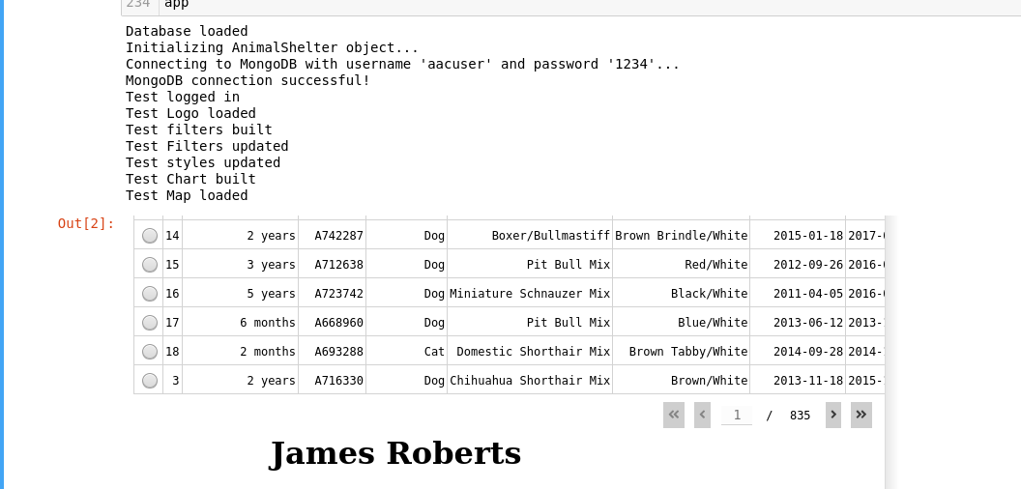
2. Starting state of dashboard.

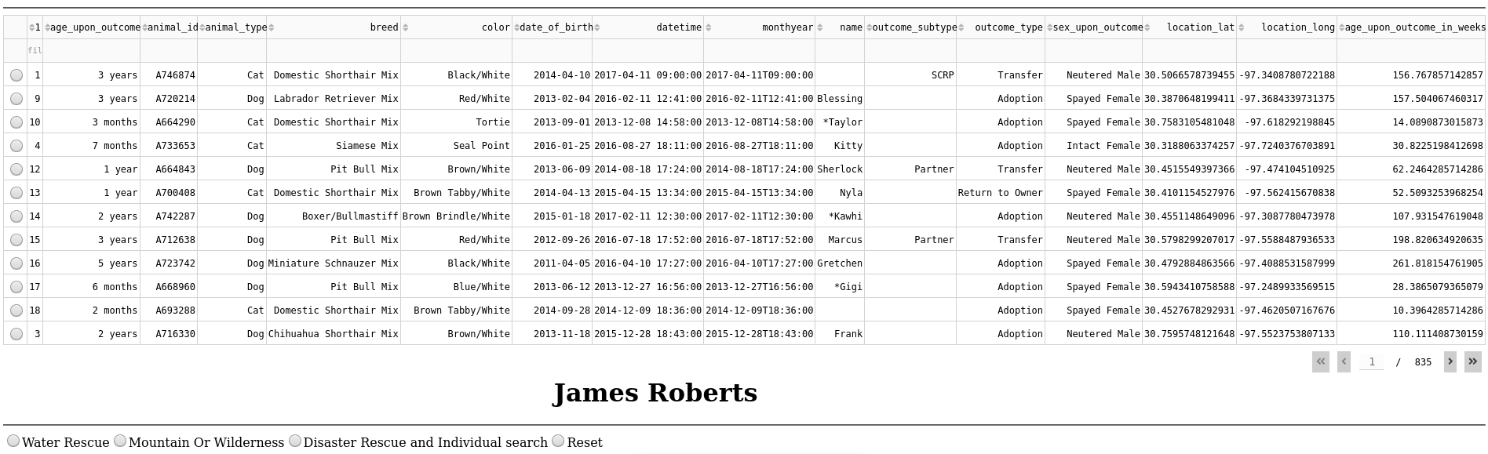State of dashboard with water rescue.

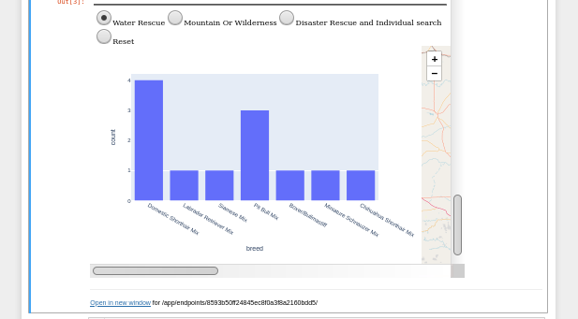

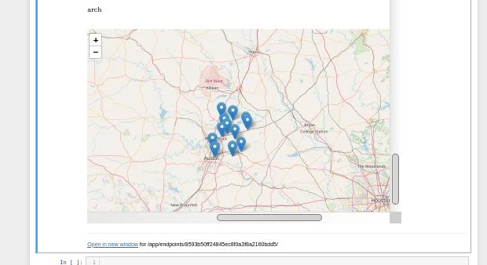

1. State of dashboard with mountain rescue

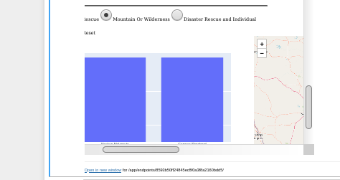

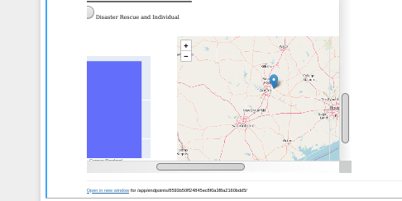

1. State of dashboard with disaster

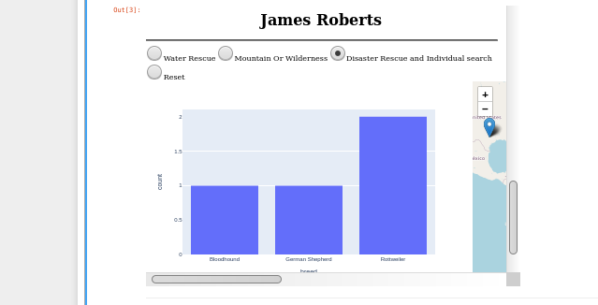

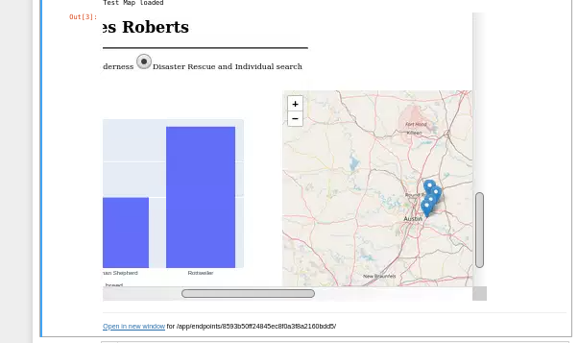

1. State of dashboard with reset

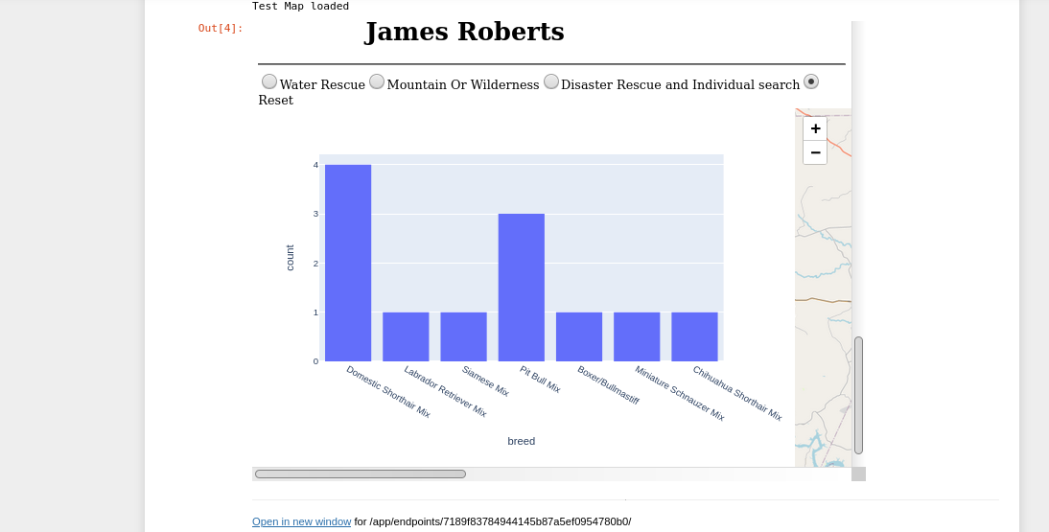

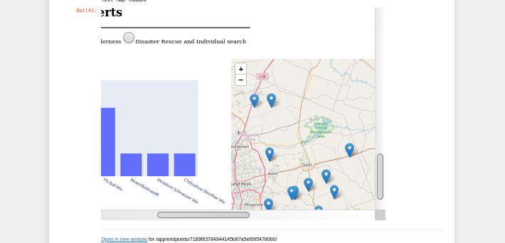

## Contact

Your name: James Roberts